**1. Parallel GC**

**Анализ.**

Запускаем программу в классе «Menu». При запуске в хип поступило 6 мегабайт объектов, далее наблюдается поднятие почти до 8 и происходит малая сборка мусора. Далее опять поднятие почти до 8 и снова сборка:

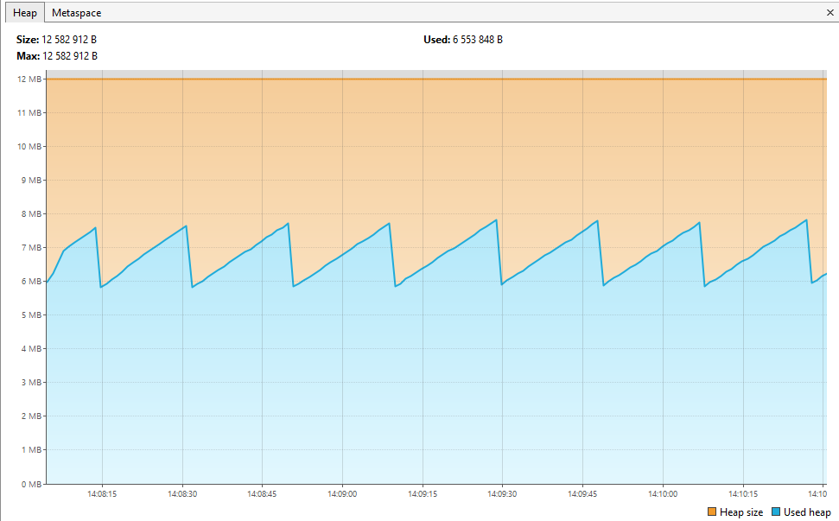

На вкладке **Sampler** можно отследить количество объектов каждого типа:

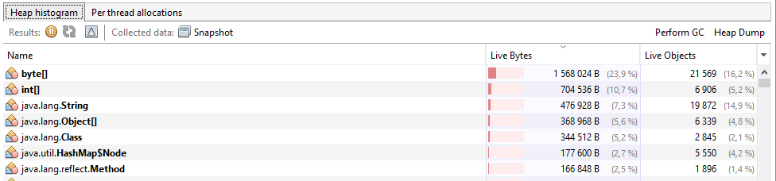  
Далее создаем массив на 250000 элементов. После создания массива произошла первая полная сборка мусора. После сборки мусора массив int[ ] имеет размер на 600_000+/- байт больше начального размера.

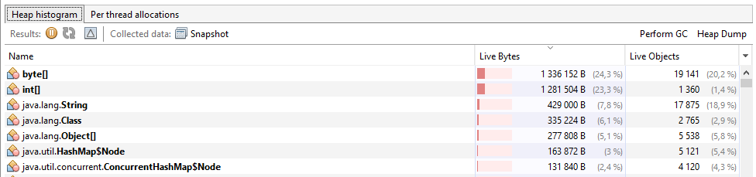

На графике этот процесс отобразился так:

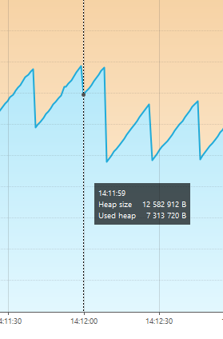

**Создание массива**

**Полная сборка мусора**

**Сортировка слиянием.**

Делаем сортировку слиянием и видим, что объем int[ ] вырос на 2_350_000+/- байт. Учитываем, что мы также создали клон массива(1000000+ байт). И много памяти потребовалось при разбиении на массивы (почти 1350000+ байт). Вся сортировка заняла 132 миллисекунды.

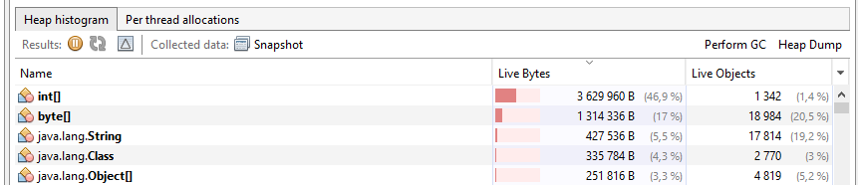

Этот резкий скачек видим на диаграмме (достигли почти 10 мегабайт):

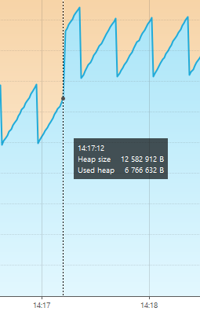

Затем было несколько малых сборок и хип теперь выглядит так:

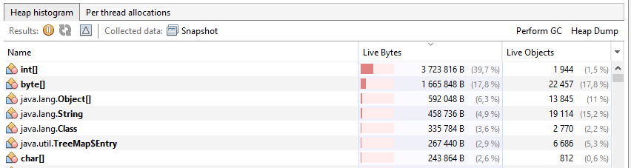

**Сортировка методом вставки.**

После сортировки произошла вторая полная сборка мусора. После сборки мусора массив int[ ] уменьшился на 1400_000+/- байт относительно начального размера. Вся сортировка заняла 9,6 секунды.

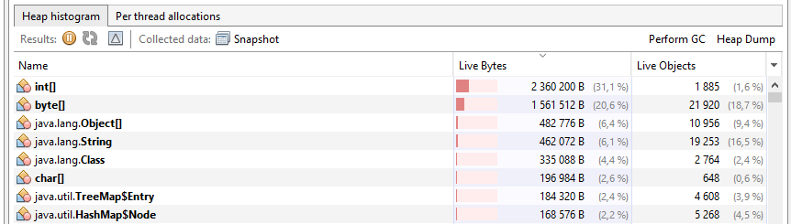

На графике этот процесс отобразился так:

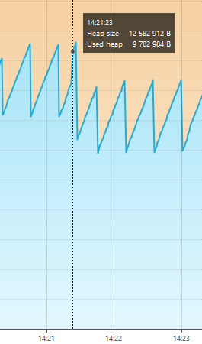

Прошло несколько малых сборок и теперь объектов стало столько:

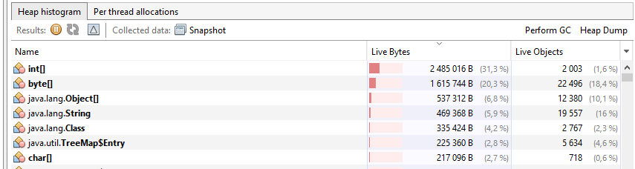

График стабилен. Идут малые сборки:

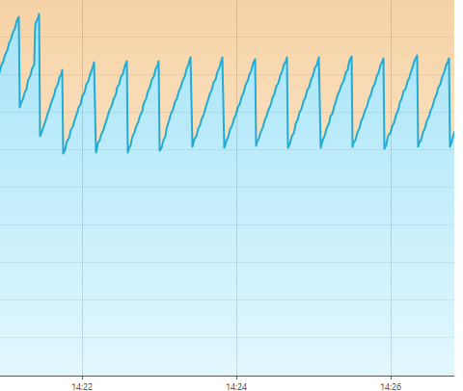

**Сортировка пузырьком.**

В хип добавился клон массива:

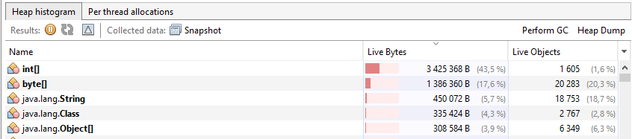Сортировка заняла 2 минуты 53 секунды.

На графике этот процесс отобразился так:

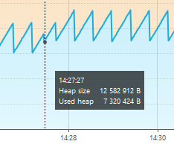

График загрузки процессора на каждой сборке. Сортировка пузырьком потребовала больше всего ресурсов процессора:

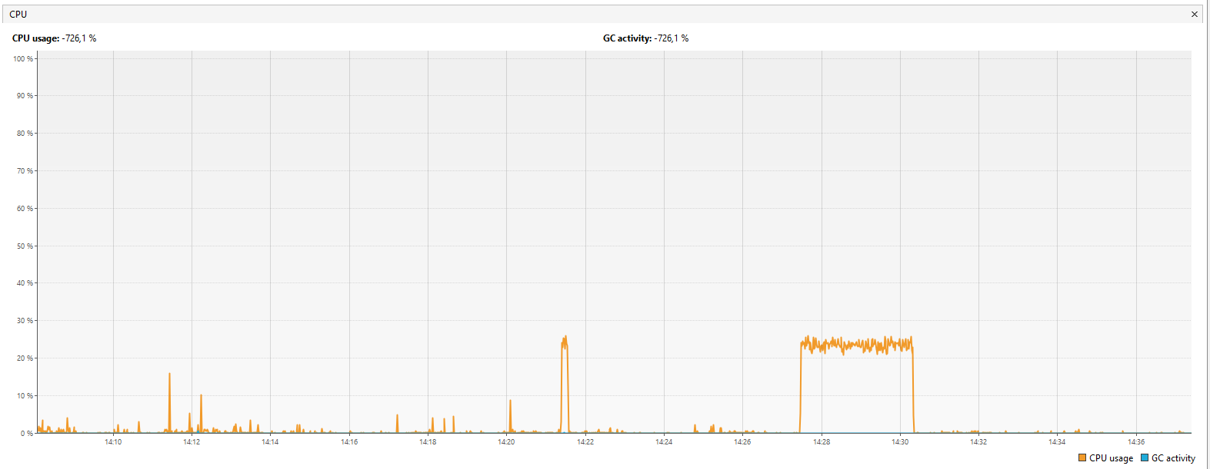

Общий график, на котором выделены сортировки:

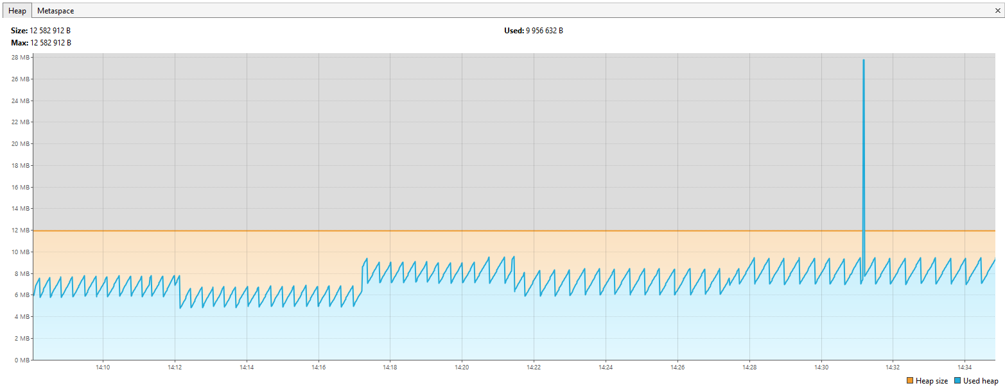

**Лог сборщика мусора:** (полные сборки выделены желтым)

[2024-04-20T14:07:51.217+0300][info][gc] Using Parallel  
[2024-04-20T14:07:51.574+0300][info][gc] GC(0) Pause Young (Allocation Failure) 3M->1M(11M) 6.189ms  
[2024-04-20T14:08:02.686+0300][info][gc] GC(1) Pause Young (Allocation Failure) 4M->2M(11M) 4.495ms  
[2024-04-20T14:08:02.828+0300][info][gc] GC(2) Pause Young (Allocation Failure) 5M->3M(11M) 3.354ms  
[2024-04-20T14:08:02.915+0300][info][gc] GC(3) Pause Young (Allocation Failure) 6M->4M(11M) 4.025ms  
[2024-04-20T14:08:02.987+0300][info][gc] GC(4) Pause Young (Allocation Failure) 7M->4M(11M) 2.652ms  
[2024-04-20T14:08:03.994+0300][info][gc] GC(5) Pause Young (Allocation Failure) 7M->5M(10M) 4.777ms  
[2024-04-20T14:08:04.640+0300][info][gc] GC(6) Pause Young (Allocation Failure) 7M->5M(11M) 4.482ms  
[2024-04-20T14:08:13.814+0300][info][gc] GC(7) Pause Young (Allocation Failure) 7M->5M(11M) 3.532ms  
[2024-04-20T14:08:31.777+0300][info][gc] GC(8) Pause Young (Allocation Failure) 7M->5M(11M) 2.411ms  
[2024-04-20T14:08:49.834+0300][info][gc] GC(9) Pause Young (Allocation Failure) 7M->5M(11M) 1.827ms  
[2024-04-20T14:09:08.863+0300][info][gc] GC(10) Pause Young (Allocation Failure) 7M->5M(11M) 0.563ms  
[2024-04-20T14:09:28.884+0300][info][gc] GC(11) Pause Young (Allocation Failure) 7M->5M(11M) 0.447ms  
[2024-04-20T14:09:47.907+0300][info][gc] GC(12) Pause Young (Allocation Failure) 7M->5M(11M) 0.394ms  
[2024-04-20T14:10:07.811+0300][info][gc] GC(13) Pause Young (Allocation Failure) 7M->5M(11M) 0.464ms  
[2024-04-20T14:10:26.824+0300][info][gc] GC(14) Pause Young (Allocation Failure) 7M->5M(11M) 0.473ms  
[2024-04-20T14:10:45.980+0300][info][gc] GC(15) Pause Young (Allocation Failure) 7M->5M(11M) 0.344ms  
[2024-04-20T14:11:05.844+0300][info][gc] GC(16) Pause Young (Allocation Failure) 7M->5M(11M) 0.432ms  
[2024-04-20T14:11:21.023+0300][info][gc] GC(17) Pause Young (Allocation Failure) 7M->5M(11M) 0.350ms  
[2024-04-20T14:11:40.861+0300][info][gc] GC(18) Pause Young (Allocation Failure) 7M->5M(11M) 0.365ms  
[2024-04-20T14:11:59.067+0300][info][gc] GC(19) Pause Young (Allocation Failure) 7M->5M(11M) 0.493ms  
[2024-04-20T14:12:08.077+0300][info][gc] GC(20) Pause Young (Allocation Failure) 7M->6M(11M) 1.055ms  
[2024-04-20T14:12:08.109+0300][info][gc] GC(21) Pause Full (Ergonomics) 6M->4M(11M) 31.448ms  
[2024-04-20T14:12:26.944+0300][info][gc] GC(22) Pause Young (Allocation Failure) 6M->4M(11M) 0.588ms  
[2024-04-20T14:12:45.105+0300][info][gc] GC(23) Pause Young (Allocation Failure) 6M->4M(11M) 0.485ms  
[2024-04-20T14:13:04.127+0300][info][gc] GC(24) Pause Young (Allocation Failure) 6M->4M(11M) 0.333ms  
[2024-04-20T14:13:22.144+0300][info][gc] GC(25) Pause Young (Allocation Failure) 6M->4M(11M) 0.418ms  
[2024-04-20T14:13:41.976+0300][info][gc] GC(26) Pause Young (Allocation Failure) 6M->4M(11M) 0.347ms  
[2024-04-20T14:14:01.178+0300][info][gc] GC(27) Pause Young (Allocation Failure) 6M->4M(11M) 0.433ms  
[2024-04-20T14:14:20.987+0300][info][gc] GC(28) Pause Young (Allocation Failure) 6M->4M(11M) 0.401ms  
[2024-04-20T14:14:40.206+0300][info][gc] GC(29) Pause Young (Allocation Failure) 6M->4M(11M) 0.298ms  
[2024-04-20T14:15:00.001+0300][info][gc] GC(30) Pause Young (Allocation Failure) 6M->4M(11M) 0.258ms  
[2024-04-20T14:15:19.237+0300][info][gc] GC(31) Pause Young (Allocation Failure) 6M->4M(11M) 0.430ms  
[2024-04-20T14:15:39.256+0300][info][gc] GC(32) Pause Young (Allocation Failure) 6M->4M(11M) 0.324ms  
[2024-04-20T14:15:58.268+0300][info][gc] GC(33) Pause Young (Allocation Failure) 6M->4M(11M) 0.399ms  
[2024-04-20T14:16:18.284+0300][info][gc] GC(34) Pause Young (Allocation Failure) 6M->4M(11M) 0.302ms  
[2024-04-20T14:16:38.037+0300][info][gc] GC(35) Pause Young (Allocation Failure) 6M->4M(11M) 0.263ms  
[2024-04-20T14:16:57.321+0300][info][gc] GC(36) Pause Young (Allocation Failure) 6M->4M(11M) 0.433ms  
[2024-04-20T14:17:12.092+0300][info][gc] GC(37) Pause Young (Allocation Failure) 6M->4M(11M) 0.536ms  
[2024-04-20T14:17:12.100+0300][info][gc] GC(38) Pause Young (Allocation Failure) 6M->5M(11M) 0.478ms  
[2024-04-20T14:17:12.106+0300][info][gc] GC(39) Pause Young (Allocation Failure) 7M->5M(11M) 0.704ms  
[2024-04-20T14:17:12.132+0300][info][gc] GC(40) Pause Young (Allocation Failure) 7M->6M(11M) 0.369ms  
[2024-04-20T14:17:12.165+0300][info][gc] GC(41) Pause Young (Allocation Failure) 8M->6M(11M) 0.318ms  
[2024-04-20T14:17:12.169+0300][info][gc] GC(42) Pause Young (Allocation Failure) 8M->6M(11M) 0.358ms  
[2024-04-20T14:17:12.173+0300][info][gc] GC(43) Pause Young (Allocation Failure) 8M->6M(11M) 0.495ms  
[2024-04-20T14:17:12.180+0300][info][gc] GC(44) Pause Young (Allocation Failure) 8M->6M(11M) 0.338ms  
[2024-04-20T14:17:12.186+0300][info][gc] GC(45) Pause Young (Allocation Failure) 8M->6M(11M) 0.395ms  
[2024-04-20T14:17:12.191+0300][info][gc] GC(46) Pause Young (Allocation Failure) 8M->6M(11M) 0.317ms  
[2024-04-20T14:17:12.196+0300][info][gc] GC(47) Pause Young (Allocation Failure) 8M->6M(11M) 0.353ms  
[2024-04-20T14:17:12.202+0300][info][gc] GC(48) Pause Young (Allocation Failure) 8M->7M(11M) 0.335ms  
[2024-04-20T14:17:12.206+0300][info][gc] GC(49) Pause Young (Allocation Failure) 9M->7M(11M) 0.405ms  
[2024-04-20T14:17:12.211+0300][info][gc] GC(50) Pause Young (Allocation Failure) 9M->7M(11M) 0.344ms  
[2024-04-20T14:17:12.218+0300][info][gc] GC(51) Pause Young (Allocation Failure) 8M->7M(11M) 0.340ms  
[2024-04-20T14:17:22.057+0300][info][gc] GC(52) Pause Young (Allocation Failure) 9M->7M(11M) 0.318ms  
[2024-04-20T14:17:41.363+0300][info][gc] GC(53) Pause Young (Allocation Failure) 9M->7M(11M) 0.459ms  
[2024-04-20T14:18:01.380+0300][info][gc] GC(54) Pause Young (Allocation Failure) 9M->7M(11M) 0.335ms  
[2024-04-20T14:18:21.396+0300][info][gc] GC(55) Pause Young (Allocation Failure) 9M->7M(11M) 0.319ms  
[2024-04-20T14:18:41.407+0300][info][gc] GC(56) Pause Young (Allocation Failure) 9M->7M(11M) 0.463ms  
[2024-04-20T14:19:01.423+0300][info][gc] GC(57) Pause Young (Allocation Failure) 9M->7M(11M) 0.345ms  
[2024-04-20T14:19:21.111+0300][info][gc] GC(58) Pause Young (Allocation Failure) 9M->7M(11M) 0.306ms  
[2024-04-20T14:19:41.115+0300][info][gc] GC(59) Pause Young (Allocation Failure) 9M->7M(11M) 0.399ms  
[2024-04-20T14:20:00.470+0300][info][gc] GC(60) Pause Young (Allocation Failure) 9M->7M(11M) 0.350ms  
[2024-04-20T14:20:20.486+0300][info][gc] GC(61) Pause Young (Allocation Failure) 9M->7M(11M) 0.343ms  
[2024-04-20T14:20:46.147+0300][info][gc] GC(62) Pause Young (Allocation Failure) 9M->7M(11M) 0.393ms  
[2024-04-20T14:21:11.153+0300][info][gc] GC(63) Pause Young (Allocation Failure) 9M->7M(11M) 0.276ms  
[2024-04-20T14:21:26.545+0300][info][gc] GC(64) Pause Young (Allocation Failure) 9M->9M(11M) 0.716ms  
[2024-04-20T14:21:26.562+0300][info][gc] GC(65) Pause Full (Ergonomics) 9M->5M(11M) 17.184ms  
[2024-04-20T14:21:45.171+0300][info][gc] GC(66) Pause Young (Allocation Failure) 8M->5M(11M) 0.627ms  
[2024-04-20T14:22:10.185+0300][info][gc] GC(67) Pause Young (Allocation Failure) 8M->5M(11M) 0.584ms  
[2024-04-20T14:22:35.192+0300][info][gc] GC(68) Pause Young (Allocation Failure) 8M->5M(11M) 0.461ms  
[2024-04-20T14:23:00.204+0300][info][gc] GC(69) Pause Young (Allocation Failure) 8M->5M(11M) 0.375ms  
[2024-04-20T14:23:24.633+0300][info][gc] GC(70) Pause Young (Allocation Failure) 8M->6M(11M) 0.435ms  
[2024-04-20T14:23:49.650+0300][info][gc] GC(71) Pause Young (Allocation Failure) 8M->5M(11M) 0.315ms  
[2024-04-20T14:24:14.671+0300][info][gc] GC(72) Pause Young (Allocation Failure) 8M->6M(11M) 0.342ms  
[2024-04-20T14:24:39.689+0300][info][gc] GC(73) Pause Young (Allocation Failure) 8M->6M(11M) 0.467ms  
[2024-04-20T14:25:04.704+0300][info][gc] GC(74) Pause Young (Allocation Failure) 8M->6M(11M) 0.316ms  
[2024-04-20T14:25:29.724+0300][info][gc] GC(75) Pause Young (Allocation Failure) 8M->6M(11M) 0.352ms  
[2024-04-20T14:25:55.277+0300][info][gc] GC(76) Pause Young (Allocation Failure) 8M->6M(11M) 0.295ms  
[2024-04-20T14:26:20.288+0300][info][gc] GC(77) Pause Young (Allocation Failure) 8M->5M(11M) 0.423ms  
[2024-04-20T14:26:45.795+0300][info][gc] GC(78) Pause Young (Allocation Failure) 8M->6M(11M) 0.329ms  
[2024-04-20T14:27:10.812+0300][info][gc] GC(79) Pause Young (Allocation Failure) 8M->6M(11M) 0.393ms  
[2024-04-20T14:27:27.100+0300][info][gc] GC(80) Pause Young (Allocation Failure) 7M->6M(11M) 0.340ms  
[2024-04-20T14:27:42.838+0300][info][gc] GC(81) Pause Young (Allocation Failure) 8M->7M(11M) 0.790ms  
[2024-04-20T14:28:07.853+0300][info][gc] GC(82) Pause Young (Allocation Failure) 9M->7M(11M) 0.368ms  
[2024-04-20T14:28:32.861+0300][info][gc] GC(83) Pause Young (Allocation Failure) 9M->7M(11M) 0.496ms  
[2024-04-20T14:28:58.353+0300][info][gc] GC(84) Pause Young (Allocation Failure) 9M->7M(11M) 0.456ms  
[2024-04-20T14:29:23.882+0300][info][gc] GC(85) Pause Young (Allocation Failure) 9M->7M(11M) 0.449ms  
[2024-04-20T14:29:48.894+0300][info][gc] GC(86) Pause Young (Allocation Failure) 9M->7M(11M) 0.416ms  
[2024-04-20T14:30:13.905+0300][info][gc] GC(87) Pause Young (Allocation Failure) 9M->7M(11M) 0.312ms  
[2024-04-20T14:30:39.394+0300][info][gc] GC(88) Pause Young (Allocation Failure) 9M->7M(11M) 0.342ms  
[2024-04-20T14:31:04.945+0300][info][gc] GC(89) Pause Young (Allocation Failure) 9M->7M(11M) 0.439ms  
[2024-04-20T14:31:29.968+0300][info][gc] GC(90) Pause Young (Allocation Failure) 9M->7M(11M) 0.526ms  
[2024-04-20T14:31:54.993+0300][info][gc] GC(91) Pause Young (Allocation Failure) 9M->7M(11M) 0.364ms  
[2024-04-20T14:32:20.579+0300][info][gc] GC(92) Pause Young (Allocation Failure) 9M->7M(11M) 0.386ms  
[2024-04-20T14:32:46.040+0300][info][gc] GC(93) Pause Young (Allocation Failure) 9M->7M(11M) 0.406ms  
[2024-04-20T14:33:11.062+0300][info][gc] GC(94) Pause Young (Allocation Failure) 9M->7M(11M) 0.328ms  
[2024-04-20T14:33:36.073+0300][info][gc] GC(95) Pause Young (Allocation Failure) 9M->7M(11M) 0.378ms  
[2024-04-20T14:34:01.625+0300][info][gc] GC(96) Pause Young (Allocation Failure) 9M->7M(11M) 0.268ms  
[2024-04-20T14:34:27.116+0300][info][gc] GC(97) Pause Young (Allocation Failure) 9M->7M(11M) 0.315ms  
[2024-04-20T14:34:52.136+0300][info][gc] GC(98) Pause Young (Allocation Failure) 9M->7M(11M) 0.531ms  
[2024-04-20T14:35:17.655+0300][info][gc] GC(99) Pause Young (Allocation Failure) 9M->6M(11M) 0.421ms  
[2024-04-20T14:35:43.180+0300][info][gc] GC(100) Pause Young (Allocation Failure) 9M->7M(11M) 0.394ms  
[2024-04-20T14:36:08.671+0300][info][gc] GC(101) Pause Young (Allocation Failure) 9M->7M(11M) 0.388ms  
[2024-04-20T14:36:34.223+0300][info][gc] GC(102) Pause Young (Allocation Failure) 9M->7M(11M) 0.461ms  
[2024-04-20T14:36:59.694+0300][info][gc] GC(103) Pause Young (Allocation Failure) 9M->7M(11M) 0.359ms

**2. G1 GC**

**Анализ.**

Запускаем программу. При запуске в хип поступило 4,5 мегабайт объектов, далее наблюдается поднятие до 5,5 и происходит малая сборка мусора. Далее опять поднятие до 6 и снова сборка:

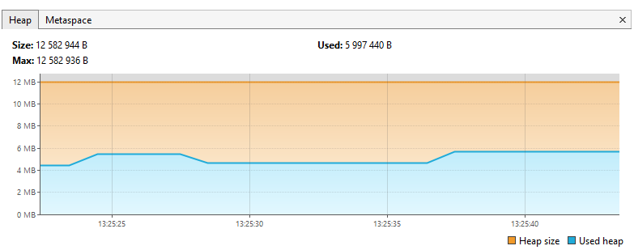Открываем вкладку **Sampler**, где можем отследить количество объектов каждого типа:

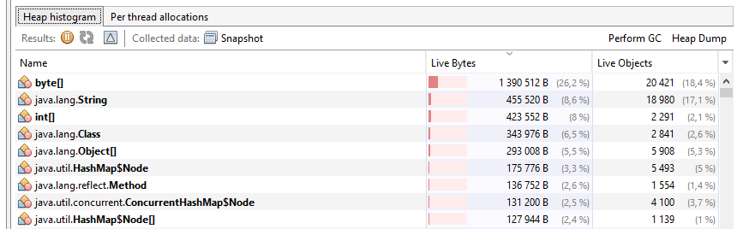

Далее создаем массив на 250000 элементов. Мы можем его заметить - int[] вырос на  размер массива (1_000_016).

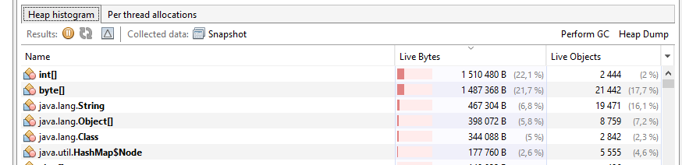

На графике этот процесс отобразился так: после создания массива идет постепенное увеличение хипа до 8 мегабайт, далее идет малая сборка и объем хипа опускается до 5 мегабайт.

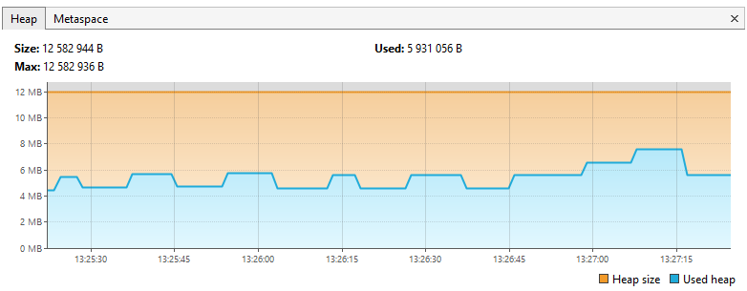**Сортировка слиянием.**

**Создание массива**

Делаем сортировку слиянием, видим резкий скачек на диаграмме до 8,5 мегабайт. Во время сортировки происходит первая смешанная сборка мусора (Mixed), т.е. очищаются также регионы старшего поколения, а так же следом происходит несколько молодых сборок. Вся сортировка заняла 200 миллисекунд. Далее происходит вторая смешанная сборка. На графике этот процесс отобразился так:

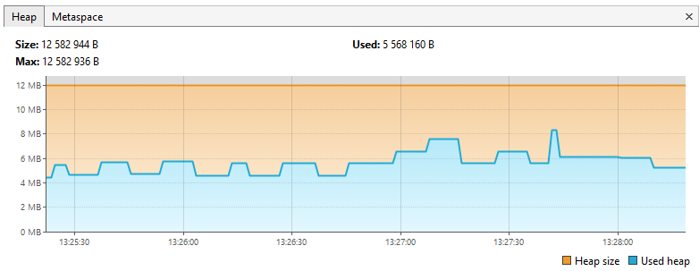

**Сортировка**

**Mixed 1**

**Mixed 2**

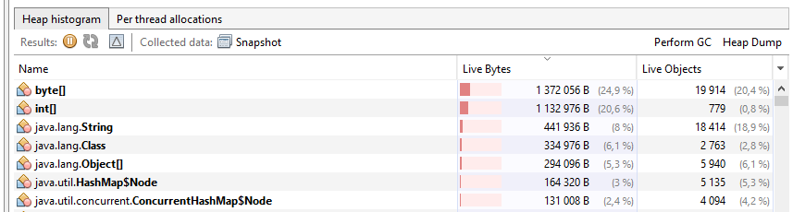

**Сортировка методом вставки.**

Теперь делаем сортировку методом вставки. Можем наблюдать, что хип вырос на размер массива:

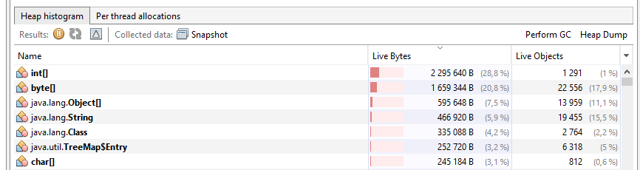

По времени процедура заняла 11 секунд. G1 GC обходится малыми сборками.

На графике этот процесс отобразился так:

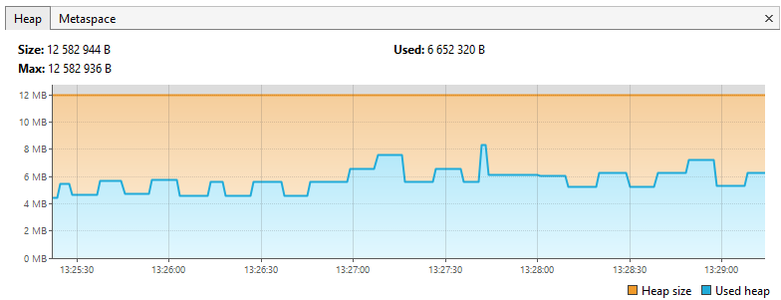

Прошло несколько малых сборок и теперь объектов стало столько:

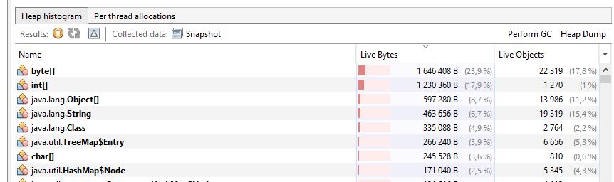

**Сортировка пузырьком.**

Начинаем сортировку пузырьком. В хип добавился клон массива:

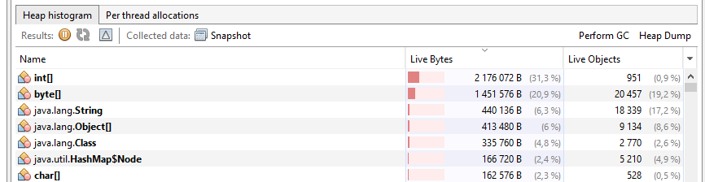По времени процедура заняла 3 минуты 6 секунд. G1 GC обходится малыми сборками. На графике этот процесс отобразился так:

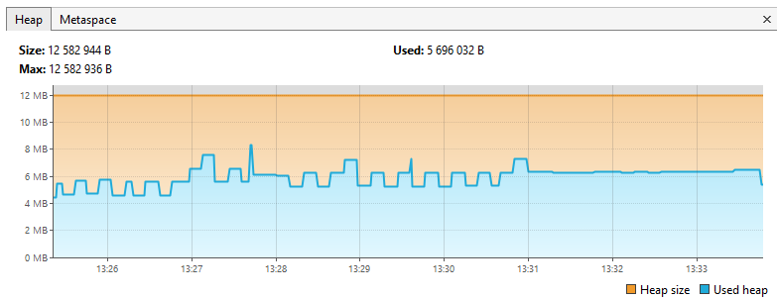

График загрузки процессора на каждой сборке. Сортировка пузырьком потребовала больше всего ресурсов процессора:

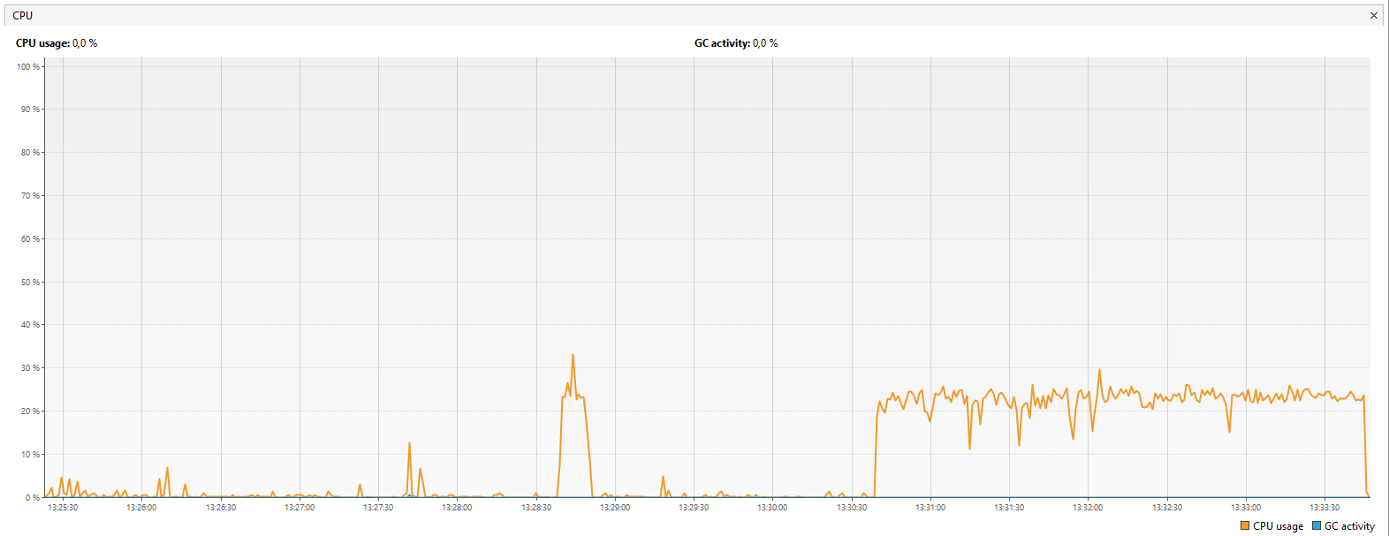

Общий график, на котором выделены сортировки:

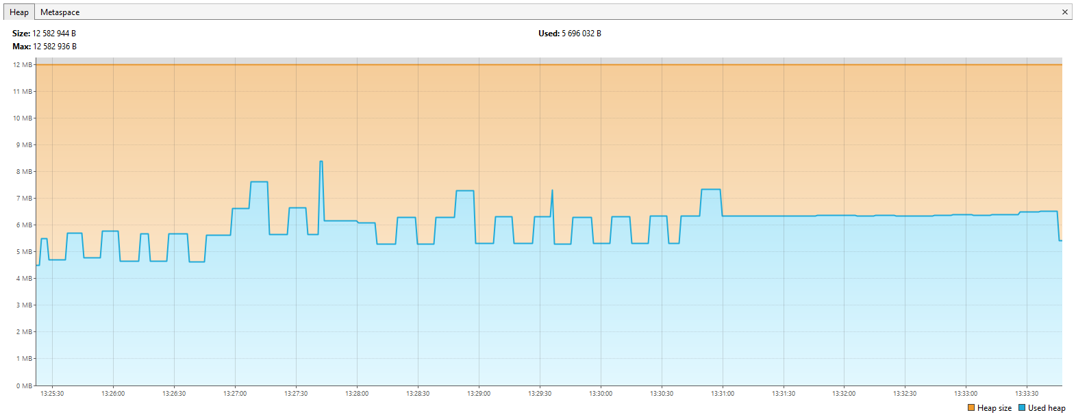

Лог сборщика мусора: (смешанные сборки выделены желтым)

[2024-04-23T13:25:15.456+0300][info][gc] Using G1  
[2024-04-23T13:25:20.069+0300][info][gc] GC(0) Pause Young (Normal) (G1 Evacuation Pause) 4M->2M(12M) 5.702ms  
[2024-04-23T13:25:20.120+0300][info][gc] GC(1) Pause Young (Normal) (G1 Evacuation Pause) 3M->2M(12M) 3.705ms  
[2024-04-23T13:25:20.170+0300][info][gc] GC(2) Pause Young (Normal) (G1 Evacuation Pause) 3M->2M(12M) 2.346ms  
[2024-04-23T13:25:20.278+0300][info][gc] GC(3) Pause Young (Normal) (G1 Evacuation Pause) 4M->2M(12M) 2.454ms  
[2024-04-23T13:25:20.394+0300][info][gc] GC(4) Pause Young (Normal) (G1 Evacuation Pause) 4M->3M(12M) 3.461ms  
[2024-04-23T13:25:20.454+0300][info][gc] GC(5) Pause Young (Normal) (G1 Evacuation Pause) 5M->3M(12M) 4.434ms  
[2024-04-23T13:25:20.491+0300][info][gc] GC(6) Pause Young (Normal) (G1 Evacuation Pause) 5M->4M(12M) 3.093ms  
[2024-04-23T13:25:21.379+0300][info][gc] GC(7) Pause Young (Normal) (G1 Evacuation Pause) 6M->3M(12M) 2.098ms  
[2024-04-23T13:25:21.591+0300][info][gc] GC(8) Pause Young (Normal) (G1 Evacuation Pause) 5M->4M(12M) 2.420ms  
[2024-04-23T13:25:22.114+0300][info][gc] GC(9) Pause Young (Normal) (G1 Evacuation Pause) 6M->4M(12M) 7.068ms  
[2024-04-23T13:25:28.444+0300][info][gc] GC(10) Pause Young (Normal) (G1 Evacuation Pause) 6M->4M(12M) 2.791ms  
[2024-04-23T13:25:44.466+0300][info][gc] GC(11) Pause Young (Normal) (G1 Evacuation Pause) 6M->4M(12M) 2.398ms  
[2024-04-23T13:26:03.462+0300][info][gc] GC(12) Pause Young (Normal) (G1 Evacuation Pause) 6M->4M(12M) 1.268ms  
[2024-04-23T13:26:18.319+0300][info][gc] GC(13) Pause Young (Normal) (G1 Evacuation Pause) 6M->4M(12M) 1.685ms  
[2024-04-23T13:26:36.661+0300][info][gc] GC(14) Pause Young (Normal) (G1 Evacuation Pause) 6M->4M(12M) 1.677ms  
[2024-04-23T13:26:49.292+0300][info][gc] GC(15) Pause Young (Concurrent Start) (G1 Humongous Allocation) 6M->4M(12M) 1.539ms  
[2024-04-23T13:26:49.292+0300][info][gc] GC(16) Concurrent Undo Cycle  
[2024-04-23T13:26:49.292+0300][info][gc] GC(16) Concurrent Undo Cycle 0.209ms  
[2024-04-23T13:27:16.835+0300][info][gc] GC(17) Pause Young (Normal) (G1 Evacuation Pause) 8M->5M(12M) 1.706ms  
[2024-04-23T13:27:35.415+0300][info][gc] GC(18) Pause Young (Concurrent Start) (G1 Evacuation Pause) 7M->5M(12M) 1.765ms  
[2024-04-23T13:27:35.415+0300][info][gc] GC(19) Concurrent Mark Cycle  
[2024-04-23T13:27:35.437+0300][info][gc] GC(19) Pause Remark 5M->5M(12M) 6.057ms  
[2024-04-23T13:27:35.441+0300][info][gc] GC(19) Pause Cleanup 5M->5M(12M) 0.092ms  
[2024-04-23T13:27:35.442+0300][info][gc] GC(19) Concurrent Mark Cycle 26.081ms  
[2024-04-23T13:27:41.305+0300][info][gc] GC(20) Pause Young (Prepare Mixed) (G1 Evacuation Pause) 8M->6M(12M) 1.591ms  
[2024-04-23T13:27:41.313+0300][info][gc] GC(21) Pause Young (Mixed) (G1 Evacuation Pause) 7M->6M(12M) 5.151ms  
[2024-04-23T13:27:41.337+0300][info][gc] GC(22) Pause Young (Concurrent Start) (G1 Evacuation Pause) 7M->6M(12M) 1.892ms  
[2024-04-23T13:27:41.337+0300][info][gc] GC(23) Concurrent Mark Cycle  
[2024-04-23T13:27:41.355+0300][info][gc] GC(23) Pause Remark 7M->7M(12M) 4.739ms  
[2024-04-23T13:27:41.361+0300][info][gc] GC(23) Pause Cleanup 7M->7M(12M) 0.041ms  
[2024-04-23T13:27:41.362+0300][info][gc] GC(23) Concurrent Mark Cycle 24.827ms  
[2024-04-23T13:27:41.363+0300][info][gc] GC(24) Pause Young (Normal) (G1 Evacuation Pause) 7M->6M(12M) 1.534ms  
[2024-04-23T13:27:41.372+0300][info][gc] GC(25) Pause Young (Concurrent Start) (G1 Evacuation Pause) 7M->6M(12M) 1.470ms  
[2024-04-23T13:27:41.372+0300][info][gc] GC(26) Concurrent Mark Cycle  
[2024-04-23T13:27:41.376+0300][info][gc] GC(27) Pause Young (Normal) (G1 Evacuation Pause) 7M->6M(12M) 1.157ms  
[2024-04-23T13:27:41.380+0300][info][gc] GC(28) Pause Young (Normal) (G1 Evacuation Pause) 7M->6M(12M) 1.355ms  
[2024-04-23T13:27:41.385+0300][info][gc] GC(29) Pause Young (Normal) (G1 Evacuation Pause) 7M->6M(12M) 1.341ms  
[2024-04-23T13:27:41.392+0300][info][gc] GC(26) Pause Remark 7M->7M(12M) 2.652ms  
[2024-04-23T13:27:41.393+0300][info][gc] GC(30) Pause Young (Normal) (G1 Evacuation Pause) 7M->6M(12M) 0.881ms  
[2024-04-23T13:27:41.396+0300][info][gc] GC(31) Pause Young (Normal) (G1 Evacuation Pause) 7M->6M(12M) 0.862ms  
[2024-04-23T13:27:41.399+0300][info][gc] GC(32) Pause Young (Normal) (G1 Evacuation Pause) 7M->6M(12M) 0.741ms  
[2024-04-23T13:27:41.401+0300][info][gc] GC(26) Pause Cleanup 7M->7M(12M) 0.044ms  
[2024-04-23T13:27:41.401+0300][info][gc] GC(26) Concurrent Mark Cycle 28.890ms  
[2024-04-23T13:27:41.403+0300][info][gc] GC(33) Pause Young (Normal) (G1 Evacuation Pause) 7M->6M(12M) 0.780ms  
[2024-04-23T13:27:41.405+0300][info][gc] GC(34) Pause Young (Concurrent Start) (G1 Evacuation Pause) 7M->6M(12M) 0.679ms  
[2024-04-23T13:27:41.405+0300][info][gc] GC(35) Concurrent Mark Cycle  
[2024-04-23T13:27:41.411+0300][info][gc] GC(36) Pause Young (Normal) (G1 Evacuation Pause) 7M->6M(12M) 0.873ms  
[2024-04-23T13:27:41.414+0300][info][gc] GC(37) Pause Young (Normal) (G1 Evacuation Pause) 7M->6M(12M) 0.777ms  
[2024-04-23T13:27:41.418+0300][info][gc] GC(38) Pause Young (Normal) (G1 Evacuation Pause) 7M->6M(12M) 0.556ms  
[2024-04-23T13:27:41.421+0300][info][gc] GC(39) Pause Young (Normal) (G1 Evacuation Pause) 7M->6M(12M) 0.626ms  
[2024-04-23T13:27:41.424+0300][info][gc] GC(40) Pause Young (Normal) (G1 Evacuation Pause) 7M->6M(12M) 0.615ms  
[2024-04-23T13:27:41.433+0300][info][gc] GC(35) Pause Remark 7M->7M(12M) 6.229ms  
[2024-04-23T13:27:41.435+0300][info][gc] GC(41) Pause Young (Normal) (G1 Evacuation Pause) 7M->6M(12M) 0.674ms  
[2024-04-23T13:27:41.440+0300][info][gc] GC(42) Pause Young (Normal) (G1 Evacuation Pause) 7M->7M(12M) 0.811ms  
[2024-04-23T13:27:41.442+0300][info][gc] GC(35) Pause Cleanup 7M->7M(12M) 0.048ms  
[2024-04-23T13:27:41.444+0300][info][gc] GC(35) Concurrent Mark Cycle 38.408ms  
[2024-04-23T13:27:41.448+0300][info][gc] GC(43) Pause Young (Normal) (G1 Evacuation Pause) 8M->7M(12M) 1.007ms  
[2024-04-23T13:27:41.452+0300][info][gc] GC(44) Pause Young (Concurrent Start) (G1 Evacuation Pause) 8M->7M(12M) 1.180ms  
[2024-04-23T13:27:41.452+0300][info][gc] GC(45) Concurrent Mark Cycle  
[2024-04-23T13:27:41.459+0300][info][gc] GC(46) Pause Young (Normal) (G1 Evacuation Pause) 8M->7M(12M) 0.855ms  
[2024-04-23T13:27:41.463+0300][info][gc] GC(47) Pause Young (Normal) (G1 Evacuation Pause) 8M->7M(12M) 0.839ms  
[2024-04-23T13:27:41.471+0300][info][gc] GC(45) Pause Remark 7M->7M(12M) 3.151ms  
[2024-04-23T13:27:41.478+0300][info][gc] GC(45) Pause Cleanup 7M->7M(12M) 0.073ms  
[2024-04-23T13:27:41.479+0300][info][gc] GC(45) Concurrent Mark Cycle 26.935ms  
[2024-04-23T13:27:41.480+0300][info][gc] GC(48) Pause Young (Normal) (G1 Evacuation Pause) 8M->7M(12M) 0.907ms  
[2024-04-23T13:27:41.484+0300][info][gc] GC(49) Pause Young (Concurrent Start) (G1 Evacuation Pause) 8M->7M(12M) 0.830ms  
[2024-04-23T13:27:41.484+0300][info][gc] GC(50) Concurrent Mark Cycle  
[2024-04-23T13:27:41.488+0300][info][gc] GC(51) Pause Young (Normal) (G1 Evacuation Pause) 8M->7M(12M) 0.817ms  
[2024-04-23T13:27:41.502+0300][info][gc] GC(50) Pause Remark 9M->9M(12M) 3.196ms  
[2024-04-23T13:27:41.506+0300][info][gc] GC(50) Pause Cleanup 9M->9M(12M) 0.039ms  
[2024-04-23T13:27:41.506+0300][info][gc] GC(50) Concurrent Mark Cycle 21.607ms  
[2024-04-23T13:27:43.873+0300][info][gc] GC(52) Pause Young (Normal) (G1 Preventive Collection) 9M->6M(12M) 1.264ms  
[2024-04-23T13:27:51.451+0300][info][gc] GC(53) Pause Young (Concurrent Start) (G1 Evacuation Pause) 7M->6M(12M) 1.140ms  
[2024-04-23T13:27:51.451+0300][info][gc] GC(54) Concurrent Mark Cycle  
[2024-04-23T13:27:51.468+0300][info][gc] GC(54) Pause Remark 6M->6M(12M) 3.235ms  
[2024-04-23T13:27:51.474+0300][info][gc] GC(54) Pause Cleanup 6M->6M(12M) 0.046ms  
[2024-04-23T13:27:51.474+0300][info][gc] GC(54) Concurrent Mark Cycle 22.985ms  
[2024-04-23T13:28:00.463+0300][info][gc] GC(55) Pause Young (Prepare Mixed) (G1 Evacuation Pause) 7M->6M(12M) 0.972ms  
[2024-04-23T13:28:09.892+0300][info][gc] GC(56) Pause Young (Mixed) (G1 Evacuation Pause) 7M->5M(12M) 2.065ms  
[2024-04-23T13:28:29.493+0300][info][gc] GC(57) Pause Young (Concurrent Start) (G1 Evacuation Pause) 7M->5M(12M) 1.244ms  
[2024-04-23T13:28:29.493+0300][info][gc] GC(58) Concurrent Mark Cycle  
[2024-04-23T13:28:29.505+0300][info][gc] GC(58) Pause Remark 5M->5M(12M) 2.968ms  
[2024-04-23T13:28:29.513+0300][info][gc] GC(58) Pause Cleanup 5M->5M(12M) 0.040ms  
[2024-04-23T13:28:29.513+0300][info][gc] GC(58) Concurrent Mark Cycle 19.630ms  
[2024-04-23T13:28:38.658+0300][info][gc] GC(59) Pause Young (Concurrent Start) (G1 Humongous Allocation) 6M->5M(12M) 1.788ms  
[2024-04-23T13:28:38.658+0300][info][gc] GC(60) Concurrent Mark Cycle  
[2024-04-23T13:28:38.676+0300][info][gc] GC(60) Pause Remark 6M->6M(12M) 6.661ms  
[2024-04-23T13:28:38.689+0300][info][gc] GC(60) Pause Cleanup 6M->6M(12M) 0.045ms  
[2024-04-23T13:28:38.691+0300][info][gc] GC(60) Concurrent Mark Cycle 32.974ms  
[2024-04-23T13:28:57.635+0300][info][gc] GC(61) Pause Young (Normal) (G1 Evacuation Pause) 8M->5M(12M) 1.082ms  
[2024-04-23T13:29:16.660+0300][info][gc] GC(62) Pause Young (Concurrent Start) (G1 Evacuation Pause) 7M->5M(12M) 1.000ms  
[2024-04-23T13:29:16.660+0300][info][gc] GC(63) Concurrent Mark Cycle  
[2024-04-23T13:29:16.673+0300][info][gc] GC(63) Pause Remark 5M->5M(12M) 4.000ms  
[2024-04-23T13:29:16.678+0300][info][gc] GC(63) Pause Cleanup 5M->5M(12M) 0.051ms  
[2024-04-23T13:29:16.679+0300][info][gc] GC(63) Concurrent Mark Cycle 18.751ms  
[2024-04-23T13:29:36.326+0300][info][gc] GC(64) Pause Young (Normal) (G1 Evacuation Pause) 7M->5M(12M) 1.254ms  
[2024-04-23T13:29:55.703+0300][info][gc] GC(65) Pause Young (Concurrent Start) (G1 Evacuation Pause) 7M->5M(12M) 0.798ms  
[2024-04-23T13:29:55.703+0300][info][gc] GC(66) Concurrent Mark Cycle  
[2024-04-23T13:29:55.725+0300][info][gc] GC(66) Pause Remark 5M->5M(12M) 4.791ms  
[2024-04-23T13:29:55.729+0300][info][gc] GC(66) Pause Cleanup 5M->5M(12M) 0.090ms  
[2024-04-23T13:29:55.729+0300][info][gc] GC(66) Concurrent Mark Cycle 26.326ms  
[2024-04-23T13:30:14.725+0300][info][gc] GC(67) Pause Young (Normal) (G1 Evacuation Pause) 7M->5M(12M) 1.147ms  
[2024-04-23T13:30:33.395+0300][info][gc] GC(68) Pause Young (Concurrent Start) (G1 Evacuation Pause) 7M->5M(12M) 1.042ms  
[2024-04-23T13:30:33.395+0300][info][gc] GC(69) Concurrent Mark Cycle  
[2024-04-23T13:30:33.416+0300][info][gc] GC(69) Pause Remark 5M->5M(12M) 5.601ms  
[2024-04-23T13:30:33.420+0300][info][gc] GC(69) Pause Cleanup 5M->5M(12M) 0.046ms  
[2024-04-23T13:30:33.420+0300][info][gc] GC(69) Concurrent Mark Cycle 25.085ms  
[2024-04-23T13:30:38.871+0300][info][gc] GC(70) Pause Young (Concurrent Start) (G1 Humongous Allocation) 6M->5M(12M) 1.683ms  
[2024-04-23T13:30:38.871+0300][info][gc] GC(71) Concurrent Mark Cycle  
[2024-04-23T13:30:38.890+0300][info][gc] GC(71) Pause Remark 6M->6M(12M) 5.781ms  
[2024-04-23T13:30:38.898+0300][info][gc] GC(71) Pause Cleanup 6M->6M(12M) 0.061ms  
[2024-04-23T13:30:38.899+0300][info][gc] GC(71) Concurrent Mark Cycle 27.541ms  
[2024-04-23T13:30:58.862+0300][info][gc] GC(72) Pause Young (Normal) (G1 Evacuation Pause) 8M->6M(12M) 1.320ms  
[2024-04-23T13:31:07.867+0300][info][gc] GC(73) Pause Young (Concurrent Start) (G1 Evacuation Pause) 7M->6M(12M) 1.218ms  
[2024-04-23T13:31:07.867+0300][info][gc] GC(74) Concurrent Mark Cycle  
[2024-04-23T13:31:07.889+0300][info][gc] GC(74) Pause Remark 6M->6M(12M) 4.438ms  
[2024-04-23T13:31:07.898+0300][info][gc] GC(74) Pause Cleanup 6M->6M(12M) 0.234ms  
[2024-04-23T13:31:07.898+0300][info][gc] GC(74) Concurrent Mark Cycle 30.995ms  
[2024-04-23T13:31:17.739+0300][info][gc] GC(75) Pause Young (Normal) (G1 Evacuation Pause) 7M->6M(12M) 0.808ms  
[2024-04-23T13:31:26.894+0300][info][gc] GC(76) Pause Young (Concurrent Start) (G1 Evacuation Pause) 7M->6M(12M) 0.886ms  
[2024-04-23T13:31:26.894+0300][info][gc] GC(77) Concurrent Mark Cycle  
[2024-04-23T13:31:26.912+0300][info][gc] GC(77) Pause Remark 6M->6M(12M) 4.013ms  
[2024-04-23T13:31:26.917+0300][info][gc] GC(77) Pause Cleanup 6M->6M(12M) 0.049ms  
[2024-04-23T13:31:26.918+0300][info][gc] GC(77) Concurrent Mark Cycle 23.675ms  
[2024-04-23T13:31:36.988+0300][info][gc] GC(78) Pause Young (Normal) (G1 Evacuation Pause) 7M->6M(12M) 0.909ms  
[2024-04-23T13:31:45.924+0300][info][gc] GC(79) Pause Young (Concurrent Start) (G1 Evacuation Pause) 7M->6M(12M) 0.842ms  
[2024-04-23T13:31:45.924+0300][info][gc] GC(80) Concurrent Mark Cycle  
[2024-04-23T13:31:45.951+0300][info][gc] GC(80) Pause Remark 6M->6M(12M) 4.484ms  
[2024-04-23T13:31:45.955+0300][info][gc] GC(80) Pause Cleanup 6M->6M(12M) 0.052ms  
[2024-04-23T13:31:45.955+0300][info][gc] GC(80) Concurrent Mark Cycle 31.286ms  
[2024-04-23T13:31:56.010+0300][info][gc] GC(81) Pause Young (Normal) (G1 Evacuation Pause) 7M->6M(12M) 0.915ms  
[2024-04-23T13:32:06.054+0300][info][gc] GC(82) Pause Young (Concurrent Start) (G1 Evacuation Pause) 7M->6M(12M) 1.170ms  
[2024-04-23T13:32:06.054+0300][info][gc] GC(83) Concurrent Mark Cycle  
[2024-04-23T13:32:06.070+0300][info][gc] GC(83) Pause Remark 6M->6M(12M) 3.021ms  
[2024-04-23T13:32:06.076+0300][info][gc] GC(83) Pause Cleanup 6M->6M(12M) 0.045ms  
[2024-04-23T13:32:06.076+0300][info][gc] GC(83) Concurrent Mark Cycle 22.745ms  
[2024-04-23T13:32:15.057+0300][info][gc] GC(84) Pause Young (Normal) (G1 Evacuation Pause) 7M->6M(12M) 0.996ms  
[2024-04-23T13:32:25.063+0300][info][gc] GC(85) Pause Young (Concurrent Start) (G1 Evacuation Pause) 7M->6M(12M) 1.050ms  
[2024-04-23T13:32:25.063+0300][info][gc] GC(86) Concurrent Mark Cycle  
[2024-04-23T13:32:25.077+0300][info][gc] GC(86) Pause Remark 6M->6M(12M) 2.751ms  
[2024-04-23T13:32:25.081+0300][info][gc] GC(86) Pause Cleanup 6M->6M(12M) 0.049ms  
[2024-04-23T13:32:25.082+0300][info][gc] GC(86) Concurrent Mark Cycle 18.734ms  
[2024-04-23T13:32:34.332+0300][info][gc] GC(87) Pause Young (Normal) (G1 Evacuation Pause) 7M->6M(12M) 1.097ms  
[2024-04-23T13:32:44.076+0300][info][gc] GC(88) Pause Young (Concurrent Start) (G1 Evacuation Pause) 7M->6M(12M) 1.713ms  
[2024-04-23T13:32:44.076+0300][info][gc] GC(89) Concurrent Mark Cycle  
[2024-04-23T13:32:44.092+0300][info][gc] GC(89) Pause Remark 6M->6M(12M) 3.052ms  
[2024-04-23T13:32:44.100+0300][info][gc] GC(89) Pause Cleanup 6M->6M(12M) 0.068ms  
[2024-04-23T13:32:44.101+0300][info][gc] GC(89) Concurrent Mark Cycle 24.590ms  
[2024-04-23T13:32:53.578+0300][info][gc] GC(90) Pause Young (Normal) (G1 Evacuation Pause) 7M->6M(12M) 0.979ms  
[2024-04-23T13:33:03.242+0300][info][gc] GC(91) Pause Young (Concurrent Start) (G1 Evacuation Pause) 7M->6M(12M) 0.842ms  
[2024-04-23T13:33:03.242+0300][info][gc] GC(92) Concurrent Mark Cycle  
[2024-04-23T13:33:03.259+0300][info][gc] GC(92) Pause Remark 6M->6M(12M) 3.743ms  
[2024-04-23T13:33:03.266+0300][info][gc] GC(92) Pause Cleanup 6M->6M(12M) 0.040ms  
[2024-04-23T13:33:03.266+0300][info][gc] GC(92) Concurrent Mark Cycle 24.356ms  
[2024-04-23T13:33:12.253+0300][info][gc] GC(93) Pause Young (Normal) (G1 Evacuation Pause) 7M->6M(12M) 1.065ms  
[2024-04-23T13:33:21.564+0300][info][gc] GC(94) Pause Young (Concurrent Start) (G1 Evacuation Pause) 7M->6M(12M) 1.029ms  
[2024-04-23T13:33:21.564+0300][info][gc] GC(95) Concurrent Mark Cycle  
[2024-04-23T13:33:21.592+0300][info][gc] GC(95) Pause Remark 6M->6M(12M) 6.650ms  
[2024-04-23T13:33:21.597+0300][info][gc] GC(95) Pause Cleanup 6M->6M(12M) 0.044ms  
[2024-04-23T13:33:21.597+0300][info][gc] GC(95) Concurrent Mark Cycle 32.920ms  
[2024-04-23T13:33:26.566+0300][info][gc] GC(96) Pause Young (Normal) (G1 Evacuation Pause) 7M->6M(12M) 1.175ms  
[2024-04-23T13:33:36.289+0300][info][gc] GC(97) Pause Young (Concurrent Start) (G1 Evacuation Pause) 7M->6M(12M) 1.067ms  
[2024-04-23T13:33:36.289+0300][info][gc] GC(98) Concurrent Mark Cycle  
[2024-04-23T13:33:36.310+0300][info][gc] GC(98) Pause Remark 6M->6M(12M) 6.467ms  
[2024-04-23T13:33:36.317+0300][info][gc] GC(98) Pause Cleanup 6M->6M(12M) 0.032ms  
[2024-04-23T13:33:36.318+0300][info][gc] GC(98) Concurrent Mark Cycle 28.883ms  
[2024-04-23T13:33:45.324+0300][info][gc] GC(99) Pause Young (Normal) (G1 Evacuation Pause) 7M->5M(12M) 1.167ms

**3. ZGC**

**Анализ.**

Запускаем программу. При запуске в хип поступило 20 мегабайт объектов. Объем памяти в хипе остается постоянным.

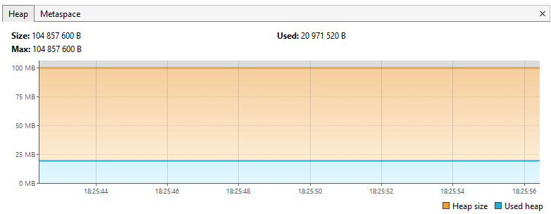

Открываем вкладку **Sampler**, где можем отследить количество объектов каждого типа:

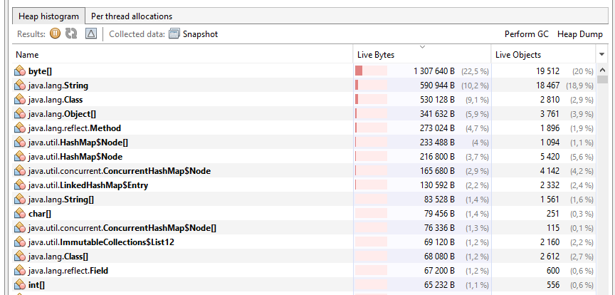

Далее создаем массив на 250000 элементов. Мы можем его заметить - int[] вырос на  размер массива (1_000_016).

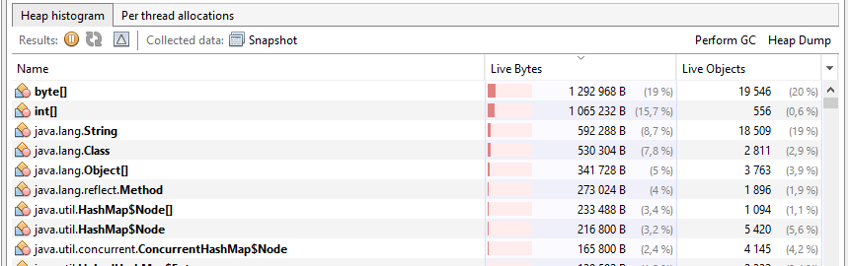

На графике этот процесс никак не отобразился:

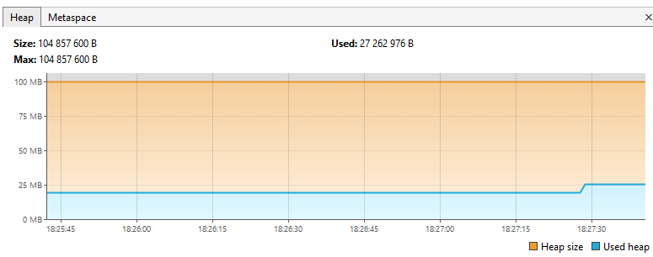

**Создание массива**

**Сортировка слиянием.**

Делаем сортировку слиянием и видим, что объем int[ ] остался на прежнем уровне. Сортировка происходит во время сборки мусора, а также сразу после сортировки происходит следущая сборка. В итоге хип уменьшается с 27 до 12 мегабайт. Вся сортировка заняла 106 миллисекунд. На графике этот процесс отобразился так:

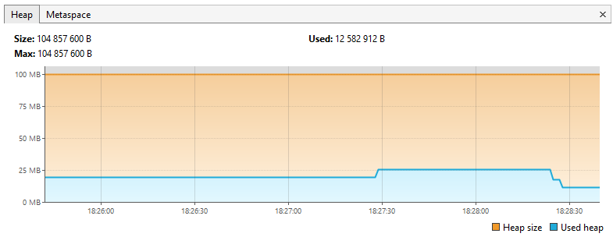

**Сортировка**

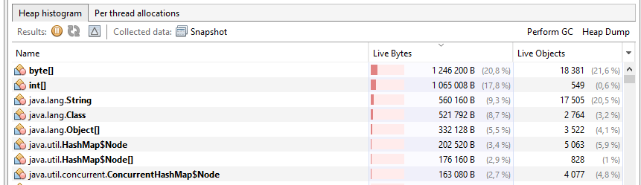

**Сортировка методом вставки.**

Теперь делаем сортировку методом вставки, видим, что объем int[ ] остался на прежнем уровне.

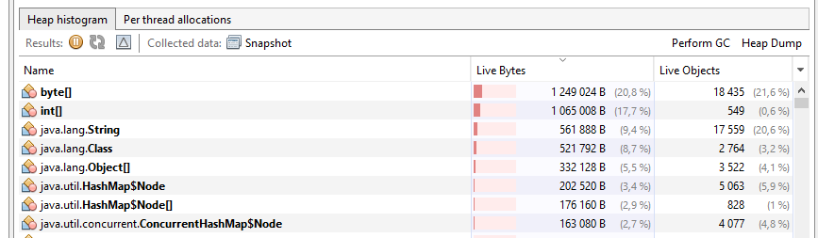

По времени процедура заняла 10,4 секунд. На графике этот процесс никак не отобразился:

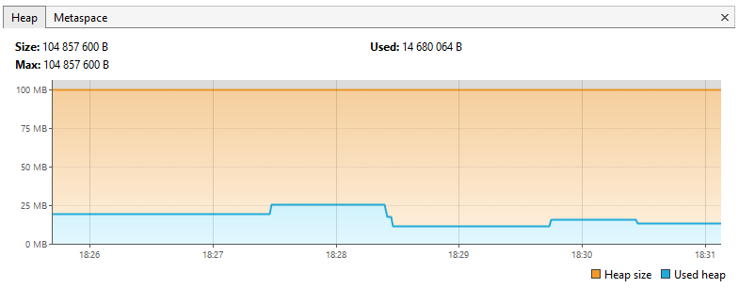

Через 5 секунд после окончания сортировки происходит сборка мусора.

**Сортировка пузырьком.**

Начинаем сортировку пузырьком. В хип добавился клон массива:

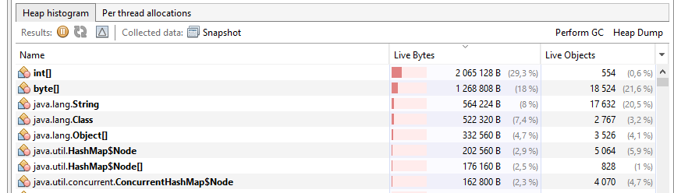  
По времени процедура заняла 3 минуты. Во время сортировки произошло три сборки мусора. На графике процесс начала сортировки никак не отобразился, заметна только последняя сборка:

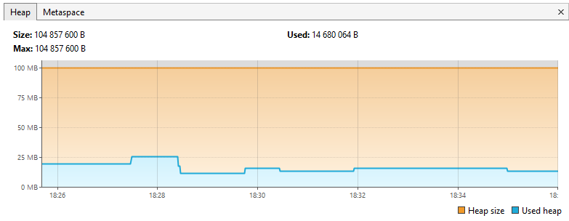

График загрузки процессора на каждой сборке. Сортировка пузырьком потребовала больше всего ресурсов процессора:

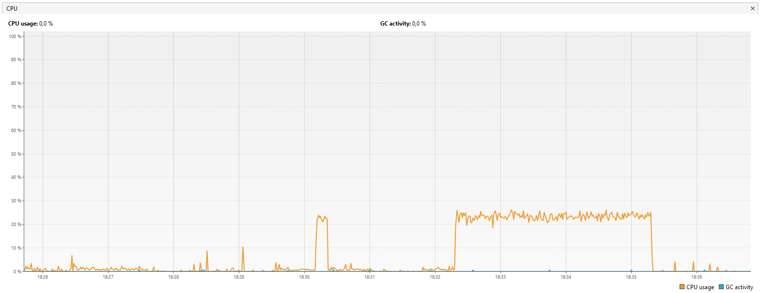

Общий график, на котором выделены сортировки:

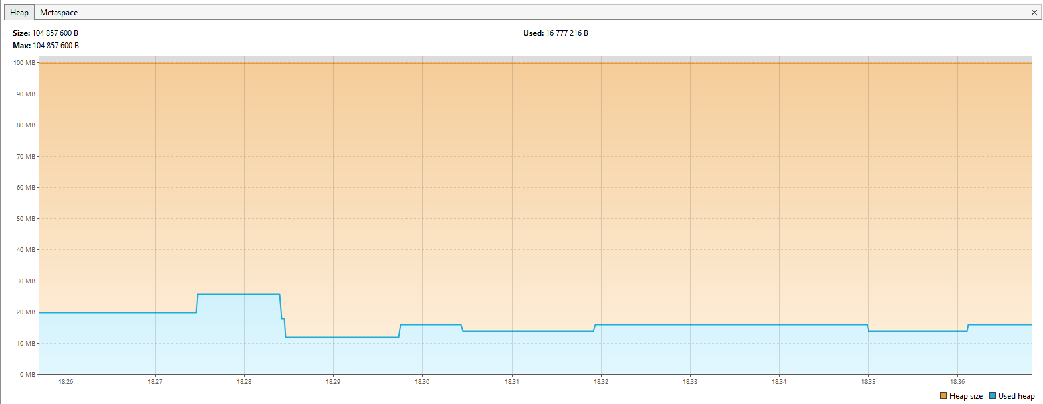

Лог сборщика мусора:

[2024-04-25T18:25:38.739+0300][info][gc] Using The Z Garbage Collector  
[2024-04-25T18:25:40.753+0300][info][gc] GC(0) Garbage Collection (Warmup) 10M(10%)->6M(6%)  
[2024-04-25T18:25:41.655+0300][info][gc] GC(1) Garbage Collection (Warmup) 20M(20%)->8M(8%)  
[2024-04-25T18:27:27.829+0300][info][gc] GC(2) Garbage Collection (Warmup) 30M(30%)->10M(10%)  
[2024-04-25T18:28:23.833+0300][info][gc] GC(3) Garbage Collection (Proactive) 20M(20%)->8M(8%)  
[2024-04-25T18:28:26.844+0300][info][gc] GC(4) Garbage Collection (Proactive) 42M(42%)->10M(10%)  
[2024-04-25T18:29:43.939+0300][info][gc] GC(5) Garbage Collection (Proactive) 20M(20%)->8M(8%)  
[2024-04-25T18:30:25.941+0300][info][gc] GC(6) Garbage Collection (Proactive) 18M(18%)->8M(8%)  
[2024-04-25T18:30:58.920+0300][info][gc] GC(7) Garbage Collection (Proactive) 18M(18%)->8M(8%)  
[2024-04-25T18:31:55.030+0300][info][gc] GC(8) Garbage Collection (Proactive) 18M(18%)->8M(8%)  
[2024-04-25T18:32:34.033+0300][info][gc] GC(9) Garbage Collection (Proactive) 18M(18%)->12M(12%)  
[2024-04-25T18:33:44.136+0300][info][gc] GC(10) Garbage Collection (Proactive) 22M(22%)->12M(12%)  
[2024-04-25T18:34:59.130+0300][info][gc] GC(11) Garbage Collection (Proactive) 22M(22%)->12M(12%)  
[2024-04-25T18:36:06.136+0300][info][gc] GC(12) Garbage Collection (Proactive) 22M(22%)->8M(8%)